docker swarm init

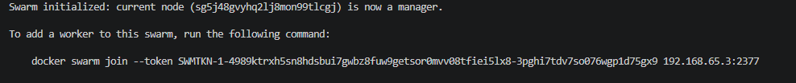
docker node ls
if you want other PC to support running your container, you need to give then a token.
In their pc you then type the following
docker swarm join --token SWMTKN-1-0v3pmc7dpe5h3hrvfwrci17rrimqgz6uo8ksiw2kdrq3sgn9vj-40ogbg0s9vda6e1tao9dmx0jb 192.168.65.3:2377
Yes, a worker is usually another machine, not just a “resource” inside the same computer.
In Docker Swarm:
- A manager is the machine that controls the cluster.
- A worker is another machine that receives and runs tasks from the manager.
So if you want more capacity, you add another physical or virtual computer and join it to the swarm as a worker. That machine then helps run your containers.
A few important points:
- It does not have to be a separate physical PC in every case; it can also be a virtual machine or a cloud server.
- It must be a separate Docker host with Docker installed.
- The manager and worker communicate over the network.
So the short answer is:
- Yes, another machine is typically needed.
- It is not just an extra “resource” inside the same host unless you are using a multi-node setup with separate Docker hosts

docker swarm leave --force

